**Azad Kashmir:**

Neelum Valley

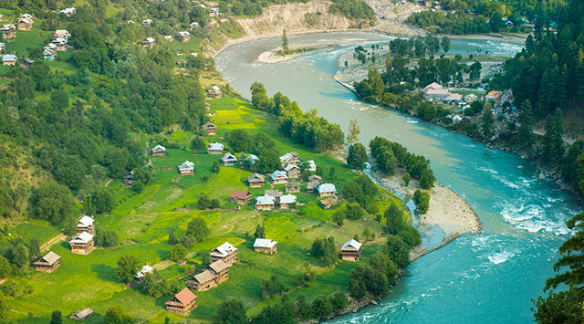

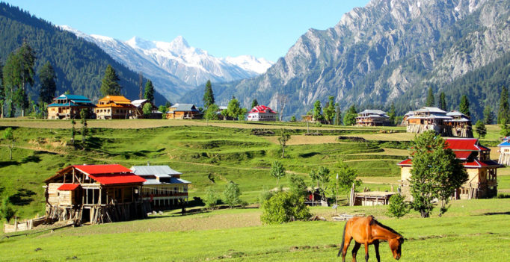

**Neelum District** (also spelt as **Neelam**; is the northernmost district of Azad Kashmir, Pakistan. Taking up the larger part of the **Neelam Valley**, the district has a population of 191,000 (as of 2017). It was badly affected by the 2005 Kashmir earthquake.